**Case Study – SQL**

**Name : Divya Sree Murali**

**Date : 09-11-2024**

**--Creating DataBase**

create database burger_bash

use burger_bash

**--Creating Table Customer_orders**

CREATE TABLE customer_orders(

order_id INTEGER NOT NULL

,customer_id INTEGER NOT NULL

,burger_id INTEGER NOT NULL

,exclusions VARCHAR(4)

,extras VARCHAR(4)

,order_time datetime null

);

alter table customer_orders add constraint pkk1 primary key (order_id,burger_id)

**--Creating tale Burger_names**

CREATE TABLE burger_names(

burger_id INTEGER NOT NULL PRIMARY KEY

,burger_name VARCHAR(10) NOT NULL

);

**--Creating Table Burger_runner**

CREATE TABLE burger_runner(

runner_id INTEGER NOT NULL PRIMARY KEY

,registration_date date NOT NULL

);

**--Creating table runner_orders**

CREATE TABLE runner_orders(

order_id INTEGER NOT NULL PRIMARY KEY

,runner_id INTEGER NOT NULL

,pickup_time datetime

,distance VARCHAR(7)

,duration VARCHAR(10)

,cancellation VARCHAR(23)

);

alter table runner_orders add constraint fk1 foreign key (runner_id) references burger_runner(runner_id)

**--Inserting records into each table**

INSERT INTO customer_orders VALUES (1,101,1,NULL,NULL,'2021-01-01 18:05:02');

INSERT INTO customer_orders VALUES (2,101,1,NULL,NULL,'2021-01-01 19:00:52');

INSERT INTO customer_orders VALUES (3,102,1,NULL,NULL,'2021-01-02 23:51:23');

INSERT INTO customer_orders VALUES (3,102,2,NULL,NULL,'2021-01-02 23:51:23');

INSERT INTO customer_orders VALUES (4,103,1,'4',NULL,'2021-01-04 13:23:46');

INSERT INTO customer_orders VALUES (4,103,2,'4',NULL,'2021-01-04 13:23:46');

INSERT INTO customer_orders VALUES (5,104,1,NULL,'1','2021-01-08 21:00:29');

INSERT INTO customer_orders VALUES (6,101,2,NULL,NULL,'2021-01-08 21:03:13');

INSERT INTO customer_orders VALUES (7,105,2,NULL,'1','2021-01-08 21:20:29');

INSERT INTO customer_orders VALUES (8,102,1,NULL,NULL,'2021-01-09 23:54:33');

INSERT INTO customer_orders VALUES (9,103,1,'4','1, 5','2021-01-10 11:22:59');

INSERT INTO customer_orders VALUES (10,104,1,NULL,NULL,'2021-01-11 18:34:49');

INSERT INTO customer_orders VALUES (10,104,2,'2, 6','1, 4','2021-01-11 18:34:49');

INSERT INTO burger_names(burger_id,burger_name) VALUES (1,'Meatlovers');

INSERT INTO burger_names(burger_id,burger_name) VALUES (2,'Vegetarian');

INSERT INTO burger_runner VALUES (1,'2021-01-01');

INSERT INTO burger_runner VALUES (2,'2021-01-03');

INSERT INTO burger_runner VALUES (3,'2021-01-08');

INSERT INTO burger_runner VALUES (4,'2021-01-15');

INSERT INTO runner_orders VALUES (1,1,'2021-01-01 18:15:34','20km','32 minutes',NULL);

INSERT INTO runner_orders VALUES (2,1,'2021-01-01 19:10:54','20km','27 minutes',NULL);

INSERT INTO runner_orders VALUES (3,1,'2021-01-03 00:12:37','13.4km','20 mins',NULL);

INSERT INTO runner_orders VALUES (4,2,'2021-01-04 13:53:03','23.4','40',NULL);

INSERT INTO runner_orders VALUES (5,3,'2021-01-08 21:10:57','10','15',NULL);

INSERT INTO runner_orders VALUES (6,3,NULL,NULL,NULL,'Restaurant Cancellation');

INSERT INTO runner_orders VALUES (7,2,'2021-01-08 21:30:45','25km','25mins',NULL);

INSERT INTO runner_orders VALUES (8,2,'2021-01-10 00:15:02','23.4 km','15 minute',NULL);

INSERT INTO runner_orders VALUES (9,2,NULL,NULL,NULL,'Customer Cancellation');

INSERT INTO runner_orders VALUES (10,1,'2021-01-11 18:50:20','10km','10minutes',NULL);

**Queries**

**2. How many unique customer orders were made?**

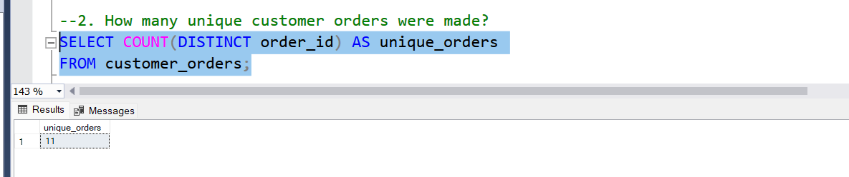

**3. How many successful orders were delivered by each runner?**

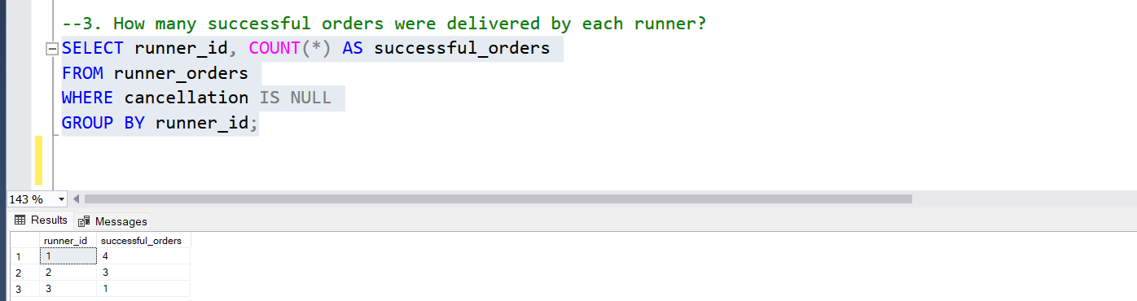

**4. How many of each type of burger was delivered?**

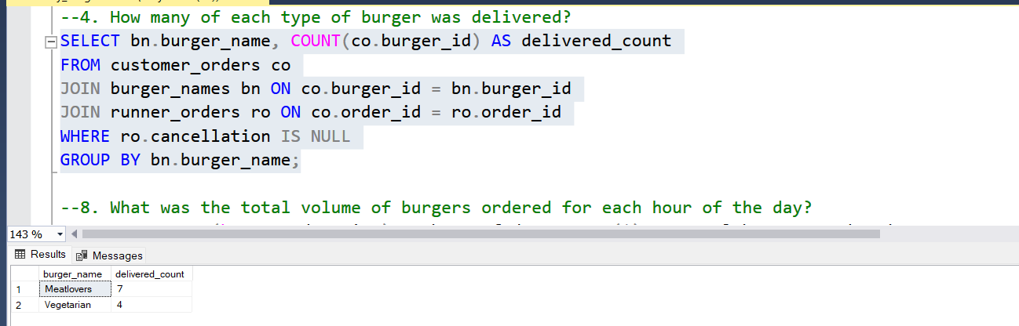

**8. What was the total volume of burgers ordered for each hour of the day?**

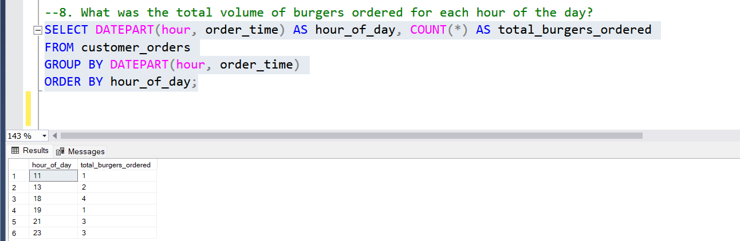

**10. What was the average distance travelled for each customer?**

